Audio file
Your Recording 1.wav

Transcript
00:00:00 Speaker 2
All right, this is just like for you know how how are you today? I'm well, yeah. I'm not too bad. Not too bad.
00:00:10 Speaker 2
So let's get down to the brass tacks. Have you ever had any facility on campus break?
00:00:19 Speaker 3
Umm, what do you mean by facility?
00:00:22 Speaker 2
So just any issue with your room?
00:00:27 Speaker 2
Or if maybe something like an appliance broke, that was.
00:00:33 Speaker 2
Like part of the university?
00:00:35 Speaker 3
I've had heaters and radiators break before, I've had washing machines break before. I used to live in France Hall my junior year and.
00:00:46 Speaker 3
There were 4 washers.
00:00:49 Speaker 3
For the entirety of the third floor and only two were ever working at one time.
00:00:56 Speaker 3
Only two. Only two.
00:00:57 Speaker 2
Wow. Uh.
00:00:58 Speaker 3
There's also another time when I.
00:01:02 Speaker 3
When I did live in.
00:01:04 Speaker 3
Francis junior year as well. I returned from winter break and the heat was.
00:01:11 Speaker 3
Tremendous to say the least. Uh, I had a fan in my room that also like had like a little temperature gauge on it and the room was over 100°F.
00:01:21 Speaker 2
If you can believe that over 100°.
00:01:23 Speaker 3
Over 100° I had plants in there and they died due to the heat and the day I got back I called maintenance about this heat and they said they weren't working that day and it was a Monday, which was odd to me.
00:01:35 Speaker 2
That is, that is really strange.
00:01:37 Speaker 3
And now in my senior year, there's only two washers per 8 townhouses, you know, the bottom of the top level and.
00:01:50 Speaker 3
One has been broken for the entirety of the adventure, and it's been almost a month. Really. Indeed.
00:01:56 Speaker 2
OK, yeah. And so you said that the washer was?
00:02:02 Speaker 3
The washer was broke, Uh.
00:02:04 Speaker 2
Since the start of the semester? Since the start of how long ago did the other facilities break?
00:02:10 Speaker 2
Um, like, just like year maybe.
00:02:12 Speaker 3
Year the 1st 2:00 that I talked about the here and the washers in Frances were my.
00:02:17 Speaker 2
Junior year. Gotcha. Gotcha. And how did they how did these things breaking affect your lifestyle?
00:02:25 Speaker 3
Well, it was just hot as hell in my room. Like I would look for like I, I lived in a solo dorm in France and I would look for any excuse to get out of there. You know, it's like I wasn't comfortable at all in my own.
00:02:38 Speaker 3
Door, right? And maintenance just did nothing about it, you know, and it was hot like that for about a week and then on the weekend, the first weekend it was fixed. So I'd spend like about 5 the five week days in this sweltering heat, you know, over 100°F. And I'm not just making that up. You know, it actually there was that I had a real thermometer that was attached to my fan and it told me what it was.
00:03:01 Speaker 3
And all my plants died and I was ****** about that.
00:03:04 Speaker 2
Yeah, very different I would imagine.
00:03:07 Speaker 2
So how how did the the multiple problems with the washers affect?
00:03:14 Speaker 2
How you lived.
00:03:14 Speaker 3
Uh, I had to like, stay up well, until the night. Mm-hmm.
00:03:20 Speaker 3
To wait for reference to be open, to wait for watchers to be open, I had to go. Like at unusual times.
00:03:28 Speaker 3
And then you know.
00:03:29 Speaker 3
It was just having to constantly walk down there and check and see if any were open.
00:03:35 Speaker 3
Umm, and that was kind of ********.
00:03:37 Speaker 2
Yeah, I'd imagine, uh, you're good. I, I, I imagine you could swear on.
00:03:41 Speaker 2
This. Oh, I can, yeah. Let it, Let it.
00:03:43 Speaker 3
Out man Umm.
00:03:46 Speaker 2
Right, right. So did you have to put in a complaint for?
00:03:51 Speaker 3
It I did, I put in complaints, I called maintenance actually, and they just told me they weren't working on Monday, the Monday that everybody got back from winter break, which I found to be odd.
00:04:05 Speaker 3
And I put in a few complaints and they weren't and just, it wasn't fixed until the weekend, right? So it just, it just felt like my requests were ignored even though I called them directly and all that.
00:04:16 Speaker 2
It just took too long.
00:04:17 Speaker 3
Actress talk to me.
00:04:18 Speaker 2
And what did the process for putting in the complaints look like?
00:04:25 Speaker 3
Umm, I went on the website and you know, you type out your problem. It's almost like sending a little e-mail to them, you know, and you.
00:04:34 Speaker 3
You don't even know if it actually got into them. You don't know if they're reading that. That's why I decided to call them directly. And then and like I said, on the Monday we got back and I called them, I put in a complaint first hand. But when you put in the complaint, it doesn't tell you that they're not working that day. It doesn't tell you when they're not in service.
00:04:52 Speaker 3
It doesn't tell you if your complaint actually reaches them or not.
00:04:57 Speaker 3
And that just, and I just have and it's, it just feels better to just call them the complaint. Umm.
00:05:05 Speaker 3
Box that they have just feels kind of worthless to be honest.
00:05:09 Speaker 2
It's not really paid attention to.
00:05:11 Speaker 2
No, no, umm, And I know you kind of already talked about this, but umm.
00:05:17 Speaker 2
How long did it take for maybe all these issues to be resolved since the point of view?
00:05:25 Speaker 2
Maybe putting in the complaint or calling?
00:05:28 Speaker 3
Uh, about a week.
00:05:29 Speaker 2
OK.
00:05:31 Speaker 3
Which you know if your room is 100° you you want it.
00:05:34 Speaker 2
Fixed that. Oh yeah, immediately.
00:05:36 Speaker 2
Yeah.
00:05:38 Speaker 2
And about the washers?
00:05:39 Speaker 3
The washers just got fixed whenever it it felt like whenever they got.
00:05:43 Speaker 3
Around to it, right?
00:05:48 Speaker 2
Umm, what?
00:05:50 Speaker 3
Oh there was never like consistency with fixing the washers and I can understand that they need to get like SER order certain parts in.
00:05:57 Speaker 3
Or they need to ask like the company for like a replacement for something. But it's still it feels it felt like they weren't on top of it as they.
00:06:06 Speaker 2
Should have been, right?
00:06:09 Speaker 2
Now what would a reasonable wait time?
00:06:13 Speaker 2
For all these issues, be.
00:06:14 Speaker 2
In your opinion?
00:06:16 Speaker 3
Considering the tuition that I'm paying here.
00:06:20 Speaker 3
Within a day or the next.
00:06:23 Speaker 3
A day or two.
00:06:24 Speaker 3
I mean, it's like I, I don't.
00:06:27 Speaker 3
I don't want to be like having to wait until the late hours of the night or the very early morning hours to like do my laundry and try and like dodge other people feel awkward about taking other people's.
00:06:40 Speaker 3
Clothes out of the washer or dryer if they've been there for like over an hour and I.
00:06:45 Speaker 3
What the tuition I'm paying for this school, I don't need to be worrying about things like that.
00:06:52 Speaker 2
I totally understand. Yeah. Umm.
00:06:56 Speaker 2
And during the waiting process.
00:07:00 Speaker 2
Did you ever like feel like you were an informed about any of this? Like did you ever get like a?
00:07:06 Speaker 2
Call back No. Never. No.
00:07:11 Speaker 2
OK, Umm. And was there any way to see progress made on the?
00:07:15 Speaker 3
Issue No, just one day I'd go in there probably like a week later and I would.
00:07:19 Speaker 3
Would be fixed OK.
00:07:21 Speaker 3
And it made it clear that it was something they just had to go in there and do very quickly.
00:07:26 Speaker 3
And.
00:07:32 Speaker 3
Never was done on times. Never was done. Yeah, they just waited a really long time, OK.
00:07:39 Speaker 2
Umm and are there any like.
00:07:41 Speaker 2
Are there any like applications on the site that can see that like you can see if something were to be in progress?
00:07:49 Speaker 3
No, nothing like that.
00:07:51 Speaker 2
Exists on the website.
00:07:53 Speaker 2
OK.
00:07:54 Speaker 3
That's why I said like, you know, it just feels better to call them and actually hear someone's voice because the.
00:07:59 Speaker 3
Stuff they have online just doesn't tell you anything.
00:08:02 Speaker 3
Right.
00:08:05 Speaker 2
Alright, right.

Audio file
Your Recording 2.wav

Transcript
00:00:00 Speaker 2
Do this um.
00:00:02 Speaker 2
Just uh, you know how how are you doing today? I'm doing good today. Right on. That's what I like to hear. Umm, can you start by giving me your year and major?
00:00:15 Speaker 2
Yeah, I'm a junior and my major is adolescent education with a concentration in history.
00:00:23 Speaker 2
Nice.
00:00:24 Speaker 2
And where are you currently living this year?
00:00:27 Speaker 2
I'm living in townhouse 32.
00:00:31 Speaker 2
Nice.
00:00:33 Speaker 2
Umm, alright, let's let's just get straight into it. Have you ever had any facility on campus break?
00:00:41 Speaker 2
Or like any.
00:00:45 Speaker 2
Like, Oh yes, yeah, it could be.
00:00:48 Speaker 2
Like a like a washing machine? Yeah, recently we had a washer break.
00:00:55 Speaker 2
Matter Townhouse.
00:00:57 Speaker 2
OK. And how long ago did it, uh, did it break?
00:01:03 Speaker 2
I think it was probably.
00:01:05 Speaker 2
Two, 2 1/2 weeks ago, OK.
00:01:09 Speaker 2
And how did this affect your lifestyle? Stay today.
00:01:14 Speaker 2
I made it really frustrating when I have to do laundry cause in laundry becomes a whole day process waiting to get the washer because now there's only one working washer under townhouse.
00:01:26 Speaker 2
Right. Umm.
00:01:29 Speaker 2
And did you end up having to put in like an FSR or a complaint?
00:01:34 Speaker 2
Yeah, I put in an FSR when I first broke, uh, two weeks ago.
00:01:41 Speaker 2
Right. And umm, what is like the process look like when you had to do that?
00:01:48 Speaker 2
The FSR page was kind of difficult to find.
00:01:53 Speaker 2
And then when I eventually found it, it was fairly easy to fill out. But I feel like.
00:01:59 Speaker 2
They haven't been too responsive since. OK, and what do you mean? Like how is it difficult to find?
00:02:08 Speaker 2
It's it was like.
00:02:12 Speaker 2
Uh, just hard to find the page to like report everything like you have to like go through like the student like website or whatever, umm, and then look it up.
00:02:22 Speaker 2
And you have to like know that FSR stands for facility service request because they fully type that out when you like, search it up. We elaborate on that. You have to know the yeah. So when you only go to like search. So what I do is like when I, when I filled it out, umm, I went on to like the my SP page and then like, I searched like facility service request, but I searched the office FSR and it didn't show up.
00:02:48 Speaker 2
And then I search up as facility service request. I did so like only a few like type it like in the search bar for the website.
00:02:56 Speaker 2
It only showed up tonight, right? So you have to be, like, specific about. Yeah. And it was just, like, frustrating to find. OK, yeah.
00:03:05 Speaker 2
OK, umm.
00:03:07 Speaker 2
And.
00:03:10 Speaker 2
And you said like it, it hasn't been resolved. Like how long did it take for this situation to?
00:03:17 Speaker 2
I mean, they got back to me probably within like a day or two.
00:03:25 Speaker 2
And said like that they were gonna work on the issue and maybe that they were like waiting for a part or something. Umm. And uh, the washer still has not been fixed like 2 1/2 weeks later so. And I haven't gotten updated since like a day or two after.
00:03:41 Speaker 2
Uh, yeah. OK. And it was just like radio silence after that. Yeah, pretty much, yeah. I think it just says in progress. Like I can pull up the FSR and it just doesn't progress. Still OK. It gives me no other updates or anything.
00:03:56 Speaker 2
Gotcha. And what would like a reasonable wait time?
00:04:00 Speaker 2
Uh, what would you say? Like would that be umm.
00:04:07 Speaker 2
I mean probably less than a week just because like it's a major inconvenience for students to have like 1 less washer when there's like a lot of people living in that same area trying to use it.
00:04:22 Speaker 2
Umm. Especially since they break often enough that I feel like if we wait long enough, another one's just gonna break and then we're gonna have none. Right? Yeah.
00:04:33 Speaker 2
Umm, OK. And like, while you were waiting, I know you kind of already talked about it, but when you were waiting, did you ever feel like informed, like through the two weeks that you've been waiting, umm, only once, and it seems like the issue might have changed.
00:04:49 Speaker 2
Because like the washer looks different now, like they've like definitely like moved it around and like done some stuff with it.
00:04:57 Speaker 2
But I have not gotten any other updates since. So like whether the issue got worse or not, like I never got updated about that. And like I don't know if other people have been filling out service requests too, but that might affect it.
00:05:09 Speaker 2
OK, um.
00:05:14 Speaker 2
And are there is there like an app to?
00:05:18 Speaker 2
I think it's just a website, just a website that I know of. And like when you go through the halls, there's QR codes that you can scan that take you to the website. But somebody told me that the QR code didn't even work recently. Somebody, I think actually today somebody was talking to me about how they had to fill out a service request for singouts and the QR code wasn't working for them.
00:05:43 Speaker 2
So OK, geez.
00:05:46 Speaker 2
And umm, how like I assume you've been on the, the, uh, the website before. Yeah, yeah. How like clear is it with the updates or like what with the information it gives you, umm.
00:06:00 Speaker 2
I feel like the information's fairly well formatted and like easy to understand.
00:06:07 Speaker 2
Uh, yeah. OK.
00:06:11 Speaker 2
Um, last question, just overall, is the process of doing all this, is it like straightforward?
00:06:20 Speaker 2
I would say.
00:06:22 Speaker 2
Kind of just because once you get onto the FSR website, it's easy, but it seems that it's kind of annoying to even get to the FSR website. And I'm sure that a lot of people like start to try and fill out an Fr then just give up on it, umm, because it might be frustrating for some people.
00:06:43 Speaker 2
But I don't think it was too terrible to do.
00:06:47 Speaker 2
OK.
00:06:48 Speaker 2
Right on. Well, I appreciate your time. Thank you.

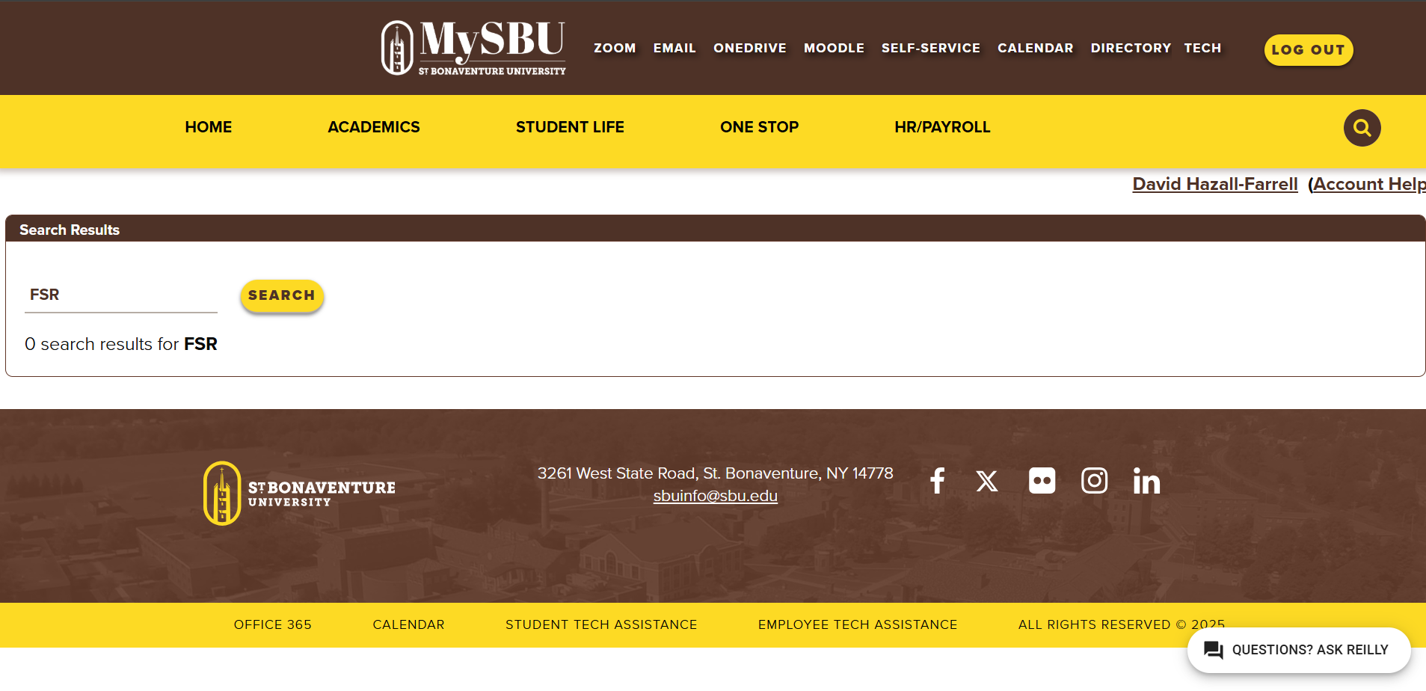
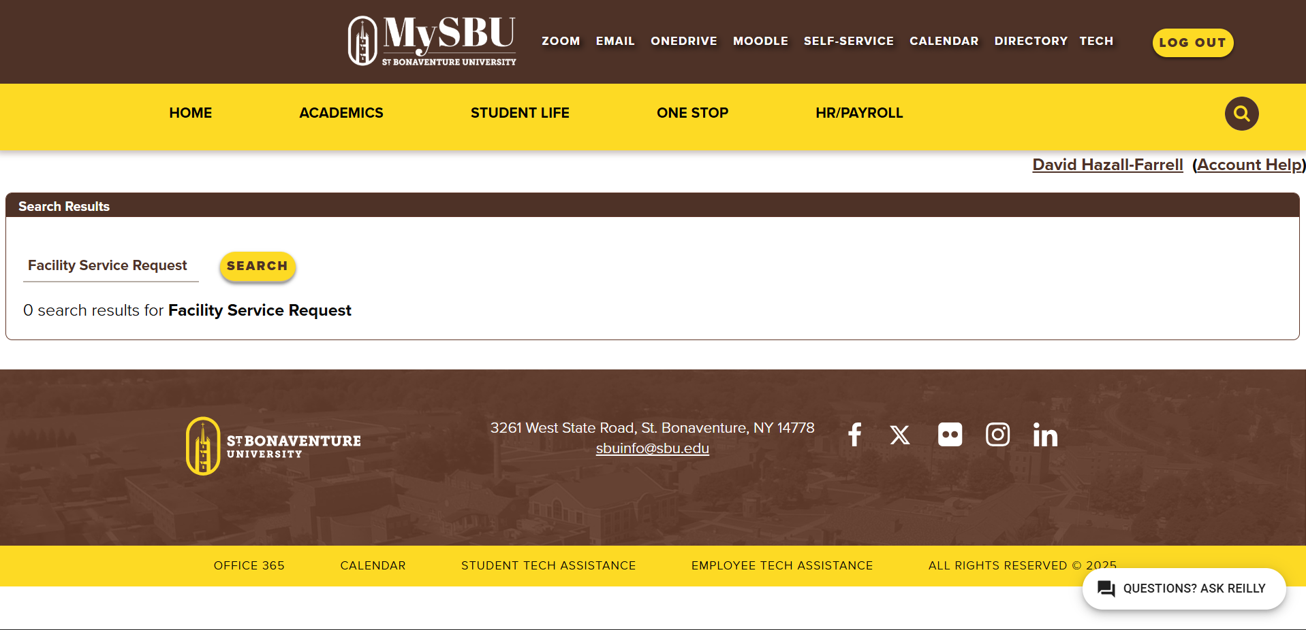
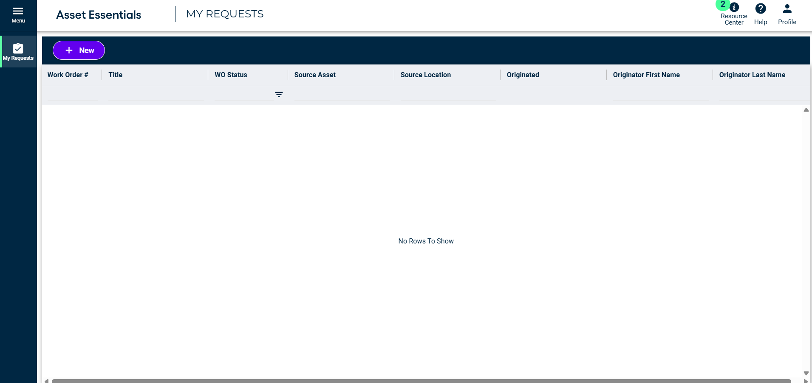

FSR request and maintenance tracking.
Hi! How’s it going today!

Can you start by giving me your year and major?

Where are you currently living this year?

Have you ever had any facility on campus break? If so, which facilities?

How long ago did these facilities break?

How did the breakage affect your lifestyle?

Did you have to put in an FSR to have it fixed?

What did the FSR process look like?

How long did it take for it to be resolved?

What is a reasonable wait time for an issue like yours?

Did you feel informed during the waiting process?

Was there any way to see progress made on the issue?

Any apps to see updates?

How clear is the app with updates?

Overall, was this process straightforward for you?

Patterns:
Breaking of washing machines
Long waiting times for the broken equipment to get fixed
Difficult or impossible to get maintenance updates
Difficult to put in an FSR
Makes life more difficult
Causes:
Bad app design
Bad communication
Common appliances breaking
Laziness
Consequences:
Harder time living. With everyone so busy with school and work, having a washing machine, or an improperly heated room can get in the way of an already busy life.
Left in the dark. With little information on the process, nobody knows when any complaint will be dealt with.
Changeable areas:
The biggest change that can be made is communication between the maintenance team and the students. By updating the application and giving feedback, students can be satisfied with the process.
Updating the process of putting in an FSR will also allow students to have easier times with having their issues resolved.
User Goals:
- Users want their broken things fixed
- They want a system that efficiently takes care of these problems
- They want a clear app with more features

User Values:
- They value their time
- They value easy solutions to their problems
- They value proper communication

Persona/ Scenario:
Kathy Bart, a resident of Francis Hall. With no car on campus. Typically spends time in Francis with her friends who are her close by neighbors. All her classes conveniently are in Francis as she’s a health science Grad student.
Recently, the printer located in Francis broke. Due to her classes requiring many assignments to be printed, this breakage is a big annoyance in her life. Due to this, she now must trek to the main campus library just to print her classwork. This adds close to 30 minutes of hassle to her days.
Kathy put in an FSR for help 3 weeks ago. The maintenance team came in 2 weeks ago to check out what had happened to the printer and said they would figure something out. After that, there was no update about the issue. Kathy had called back but was given the same answer. She accessed the app to maybe see any updates, but the only information given was about the original complaint given 3 weeks ago.

